**NEW FEATURE: In-built Email Service**

We have just uploaded an exciting new feature which is now live that gives you an email option directly from within icomplete account in addition to integrating your own email i.e outlook, Hotmail, gmail etc.

The main advantages over using your existing email or in conjunction are:

1. You can create standard email templates that can be used again and again
2. Embed url links into the email and see if the recipient has opened or clicked on the link by viewing their history record
3. Tracking responsive emails couldn’t be easier.

Here is an example:

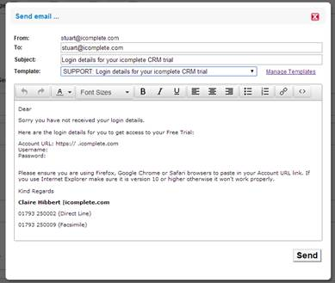

You can toggle between using your own email provider to send through icomplete as you are currently doing. But should you wish to send via the built-in icomplete email then just click on the Envelope symbol and it will pop up the internal email screen for you.